Suggested .swf Graphics for SOMR Google Earth Gallery
- Lethrinus mahsena – has barring, perhaps not quite as red as the image on the dorsal and pectoral
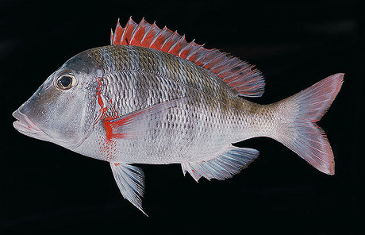

- Southern rock lobster – no claws, red coloration
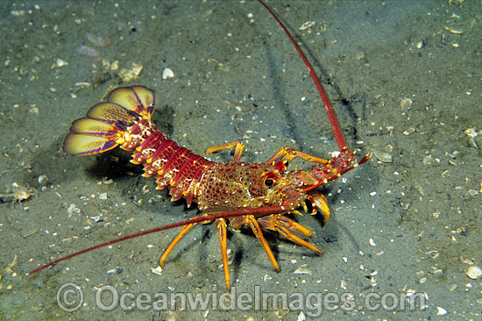

- Conch?
- Strongylocentrotus franciscanus (Red urchin) – should be easy. Just deep reddish instead of purple.
- Lethrinus nebulosus – could be used often in coral reefs
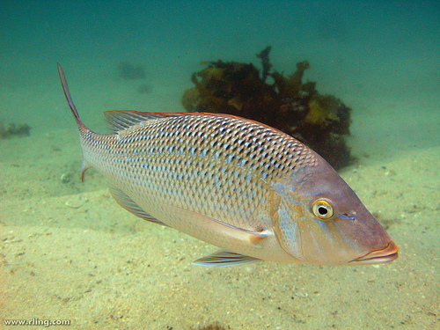

- Epinephelus tauvina – spotting, faint barring 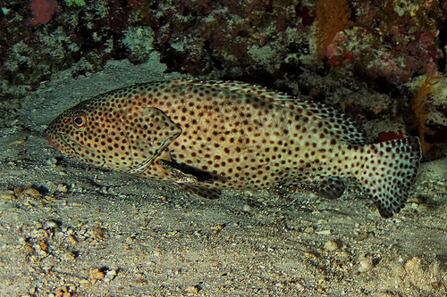

- Chaetodon auriga – threadfin butterflyfish
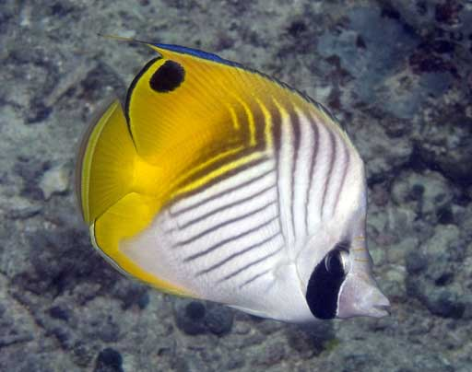

- Lethrinus atkinsoni – (Yellowtail Emperor) Good video here (yellow bar mid-body not always apparent)
http://www.divearound.com.au/fish/Yellowtail-Emperor/227

- Scarus taeniopterus – not quite as important, but could be helpful
